Pizza Sales Sql Queries

1. KPI’s
2. Total Revenue

select sum(total_price) as total_revenue from pizza_sales

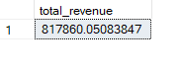

1. Average Order Value

select sum(total_price)/count(distinct order_id) as Average_order_value from pizza_sales



1. Total Pizzas Sold

select sum(total_price)/count(distinct order_id) as Average_order_value from pizza_sales



1. Total Orders Placed

select count(distinct order_id) as total_orders from pizza_sales



1. Average Pizza Per Order

select cast(sum(quantity) as decimal (10,2))/cast(count(distinct order_id) as decimal (10,2)) as avg_pizza_order from pizza_sales



B . Trend charts

1. Sales on different days

select datename(dw ,order_date) as order_day , count(distinct order_id) as total_orders from pizza_sales group by datename(dw , order_date)

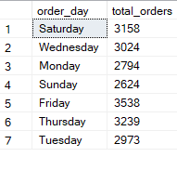

1. Sale in different month

select datename(month ,order_date) as month_name , count(distinct order_id) as total_orders from pizza_sales group by datename(month, order_date) order by total_orders desc

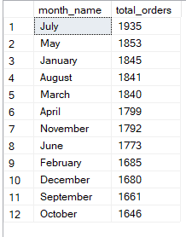

1. Percentage of Sales by Pizza Catergory

select pizza_category , sum(total_price) * 100/ (select sum(total_price) from pizza_sales) as pct_total_sales from pizza_sales group by pizza_category

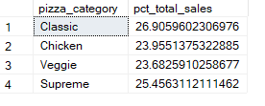

If you have to see total sales for different month then , simply change the month number in the following query

select pizza_category , sum(total_price) * 100/ (select sum(total_price) from pizza_sales where month(order_date) = 1) as pct_total_sales from pizza_sales where month(order_date) = 1 group by pizza_category

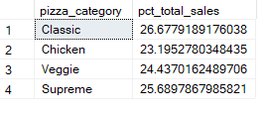

1. Percentage of Sales by Pizza Size

select pizza_size , sum(total_price) * 100/ (select sum(total_price) from pizza_sales ) as pct_total_size from pizza_sales group by pizza_size

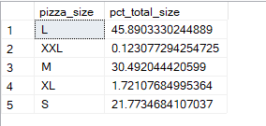

If you have to see total sales for quarter then , simply change the quarter in the following query

select pizza_size , sum(total_price) * 100/ (select sum(total_price) from pizza_sales where datepart(quarter , order_date) = 2) as pct_total_size from pizza_sales where datepart(quarter , order_date) = 2 group by pizza_size

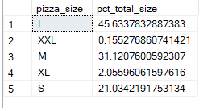

1. Top 5 Selling Pizzas

select top 5 pizza_name , sum(total_price) as total_sale from pizza_sales group by pizza_name order by total_sale desc

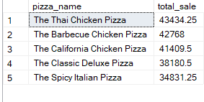

1. Bottom 5 Selling Pizzas

select top 5 pizza_name , sum(total_price) as total_sale from pizza_sales group by pizza_name order by total_sale asc

